WorkshopIII - Project 3 Report

Jack 1930026143

Exercise 1

Step1: Basic analysis

1. In order to duel with the sounds in the wave form, we should install and use the package of ” and to process the wave data.

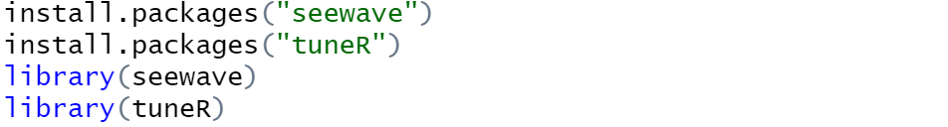

1. Read and get the .wav file by the command and the information of is shown as follow:

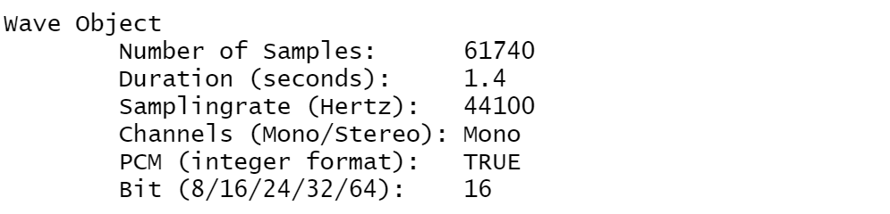

1. Get the class and duration of the wave, we can find the wave is from the package .

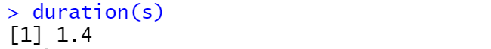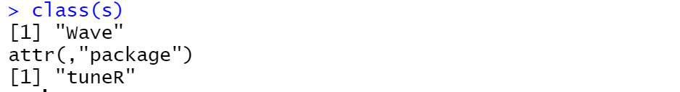

Step2: Oscillogram

1. In this step, we should extract the wave of the first call according to the time. From the original wave which has 4 calls by the command , and the first call is approximately from 0 to 0.3 second.

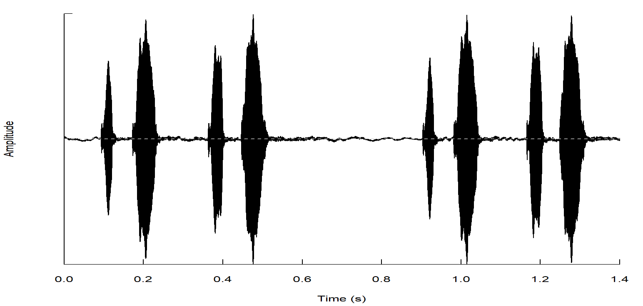

1. Then we can cut the pitch of first call and name it .



Show the gram of and we can see the patch:

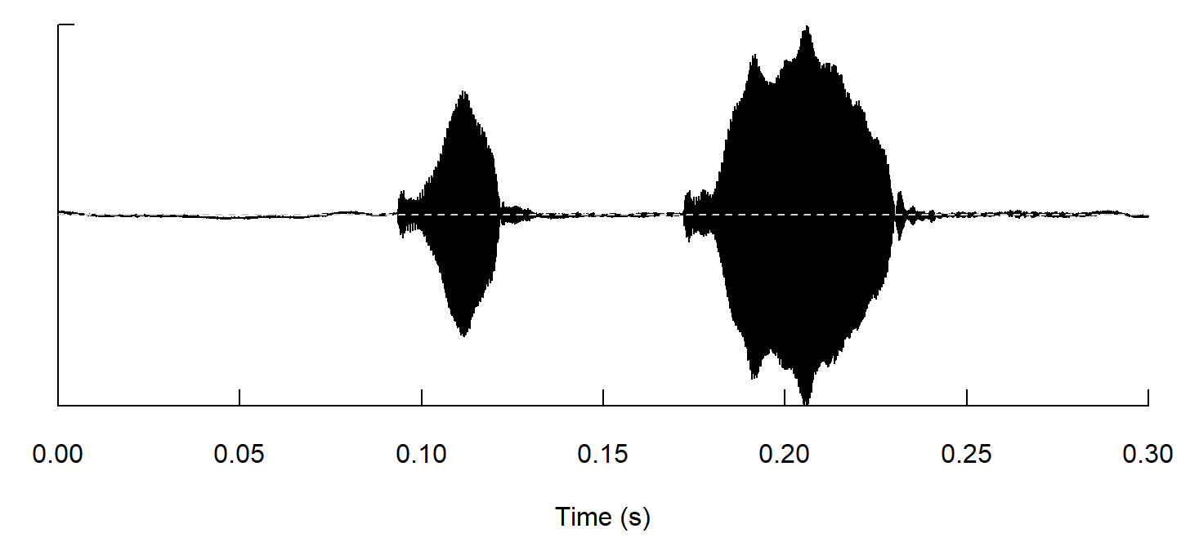

Step3: Temporal Analysis

In this part, we should take manual time measurements to c1 by the method, and we set the parameter to 3 which mean if the fluctuation of Amplitude expand the 3%, it will be marked out by the red line.

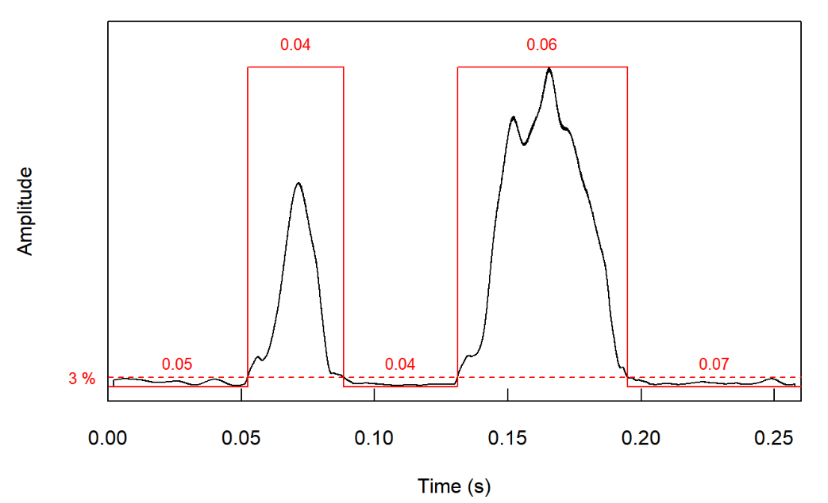

Step4. Dominant Frequency

1. In this step, we should to visualize the first call wave which was cut in the Step2 with the function . Firstly, plot the normal [spectrogram](javascript:;) of :

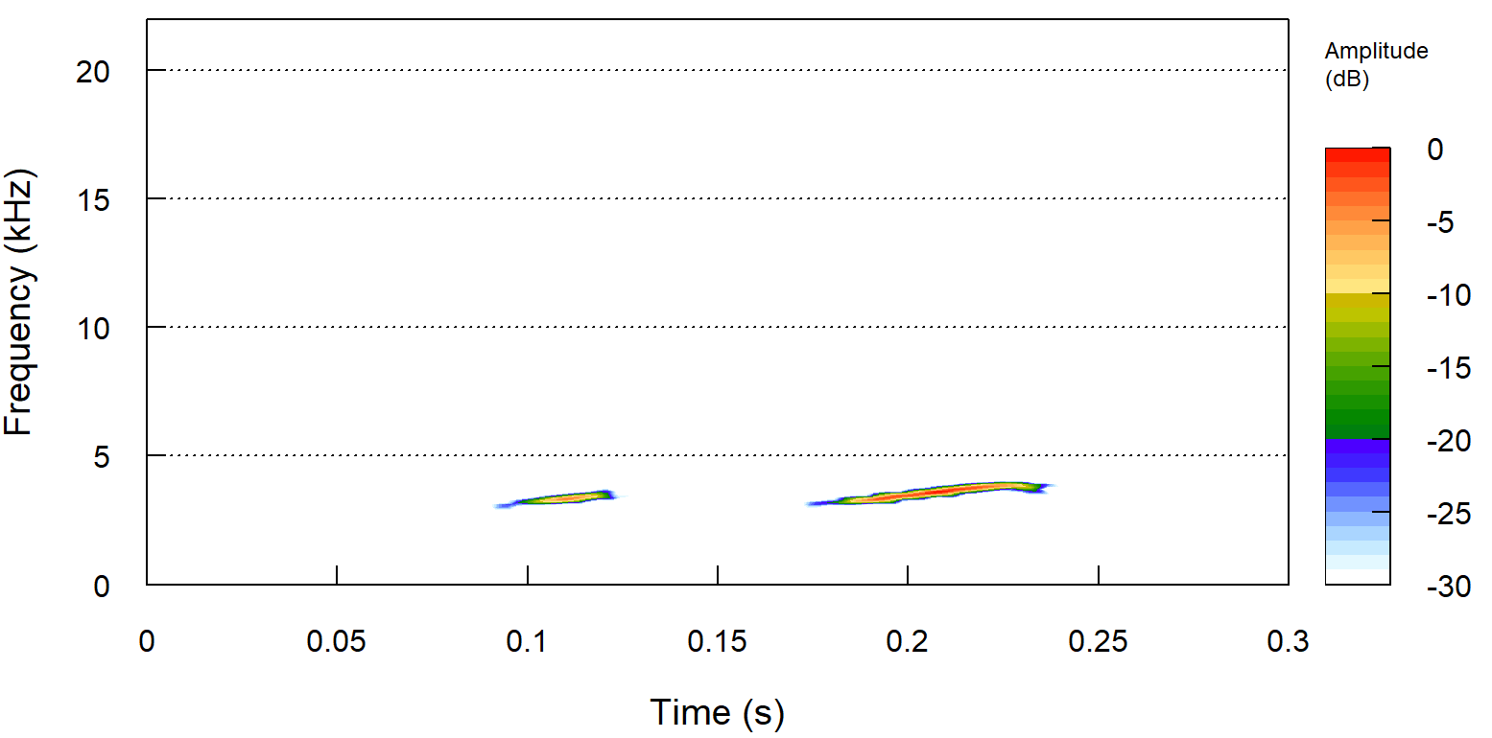

And then adjust the parameter which means to use the Fourier window: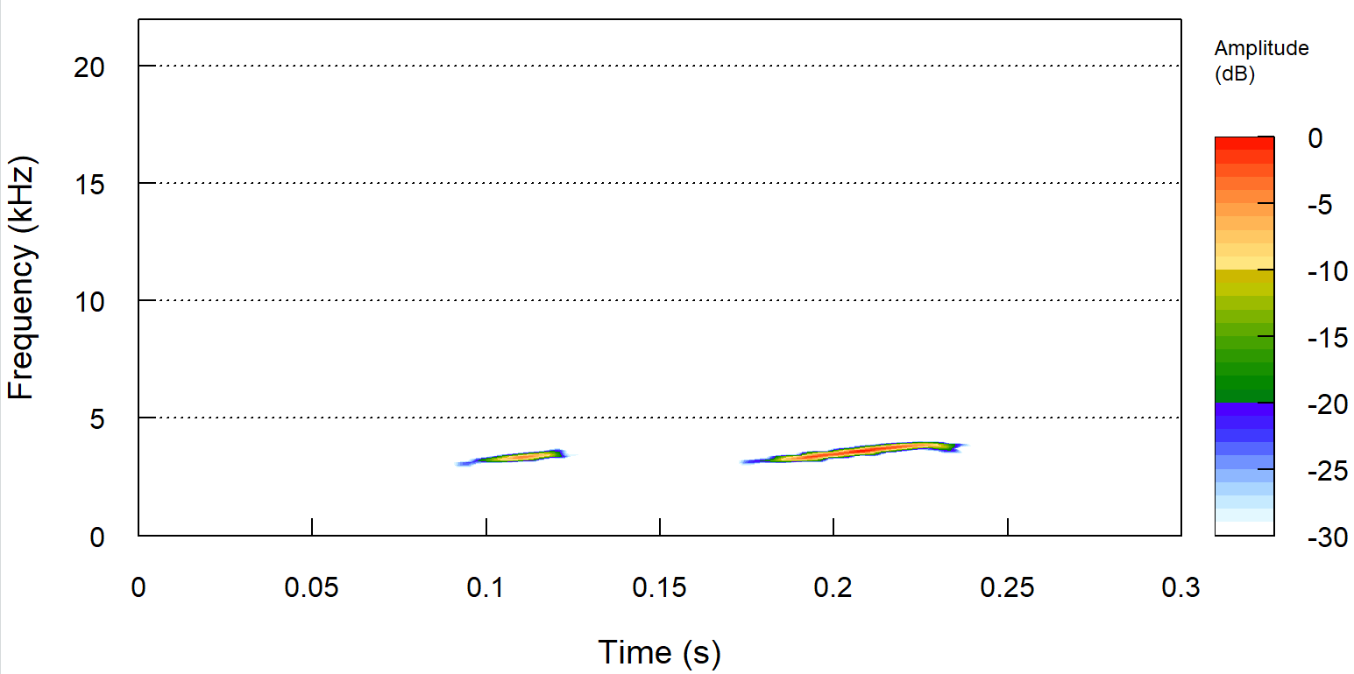

Actually, there is a slight difference between the two figures.

1. Get the dominant frequency and fundamental frequency of :

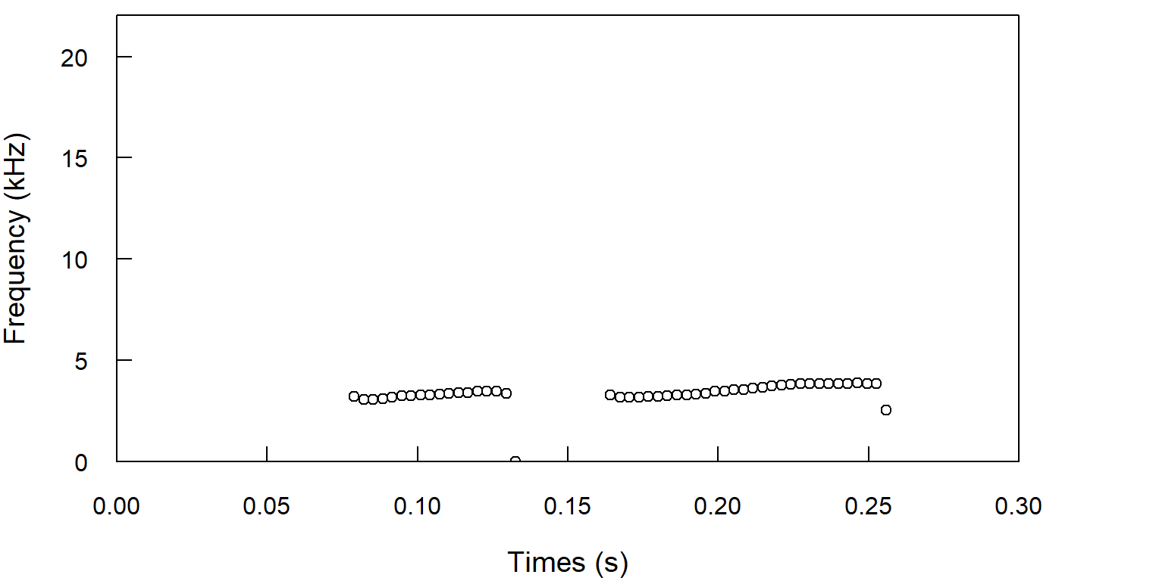 by the

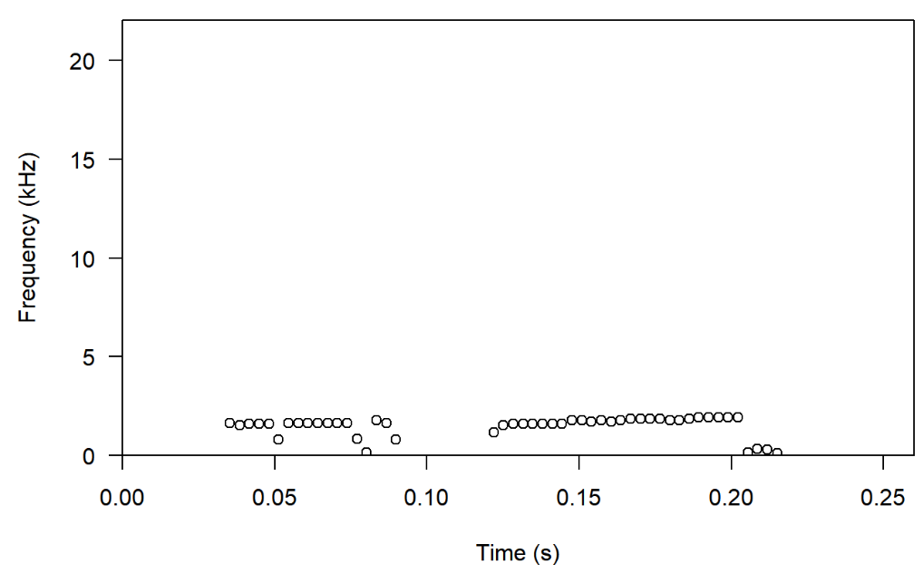 by the

Step5: Spectral Analysis

In this step, we should calculate the average spectrum of the first note of, and get the main feature of the average spectrum, the peak frequency.

1. Get the timer of the which contains the summary information: each start time, end time and other basic feathers.

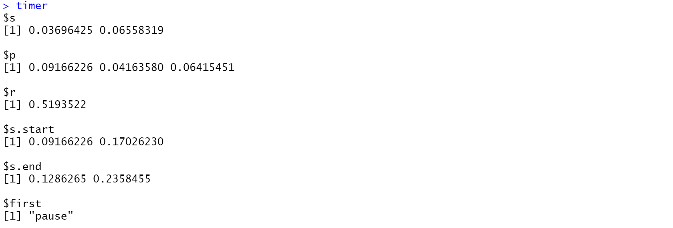

1. Then we can Compute the mean frequency spectrum of c1:

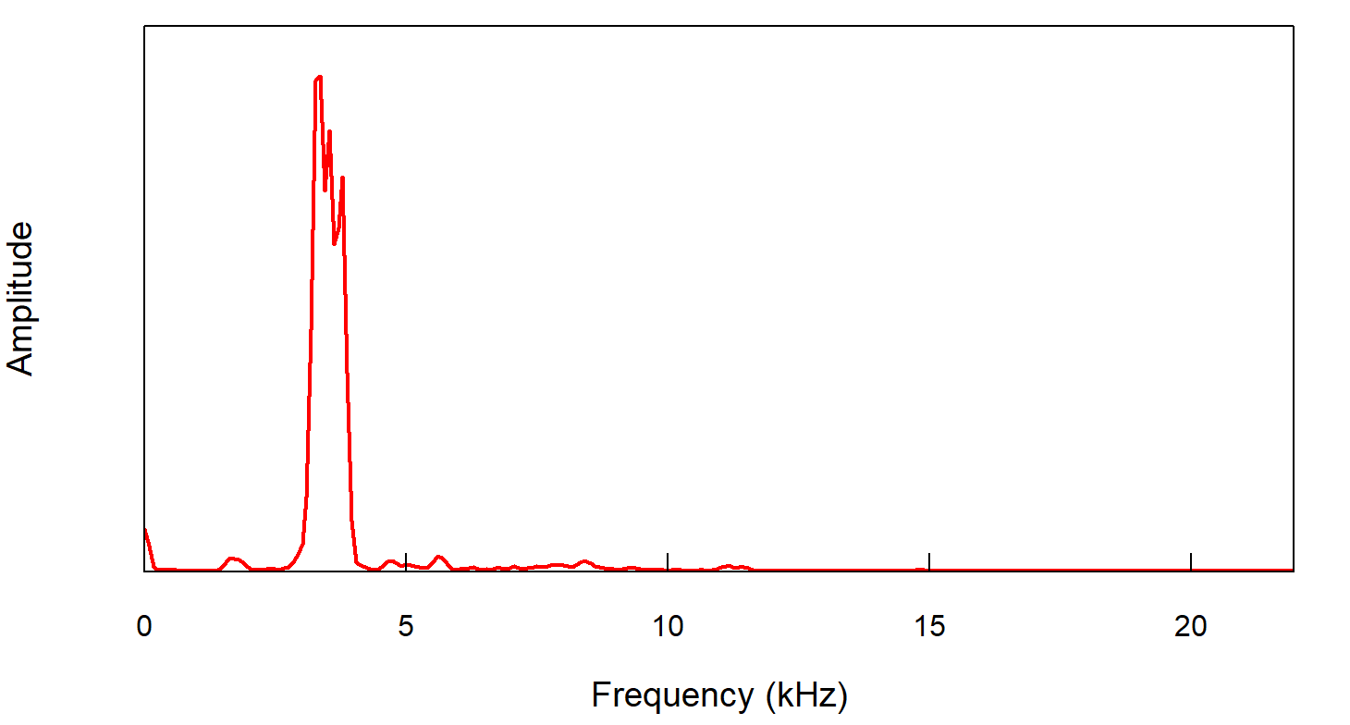 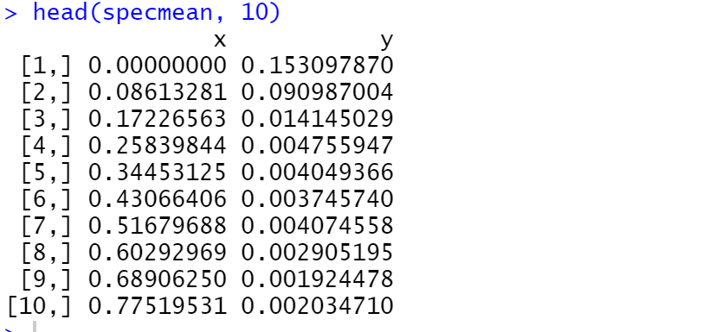

1. Find the main frequency peaks：

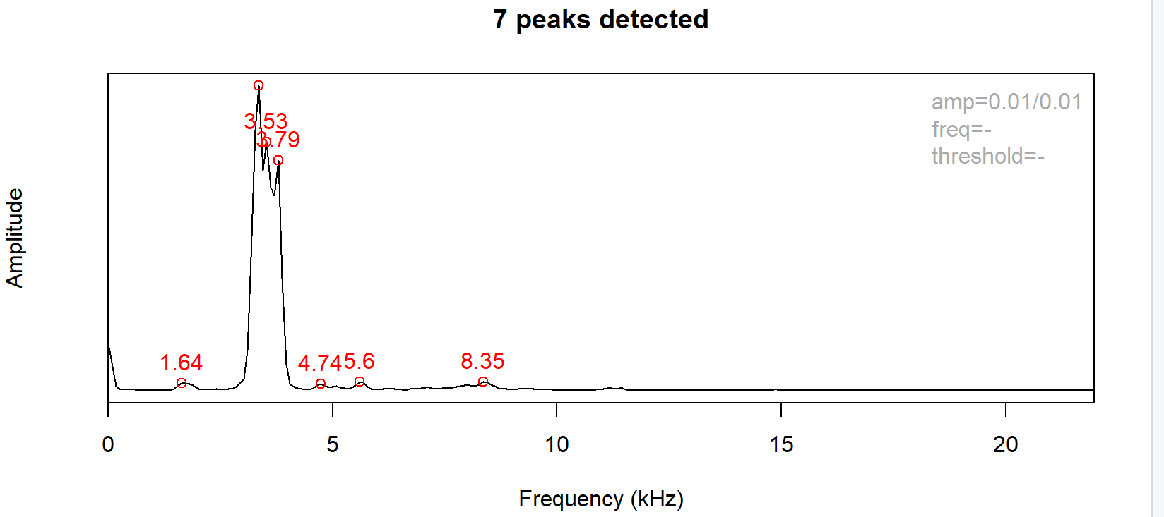

1. 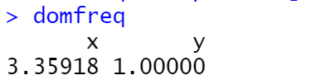Get the main properties and dominant frequent：
2. Plot the spectrogram of frequencies:

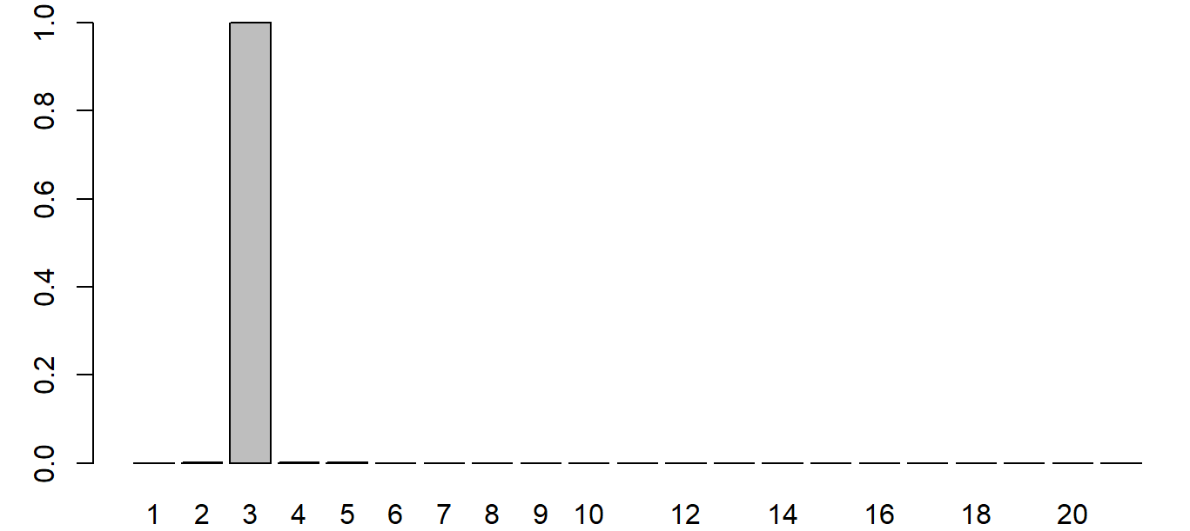

Exercise 2:

Step1: Basic operation

1. Install and load the libraries and set the path



1. Play a file by the command

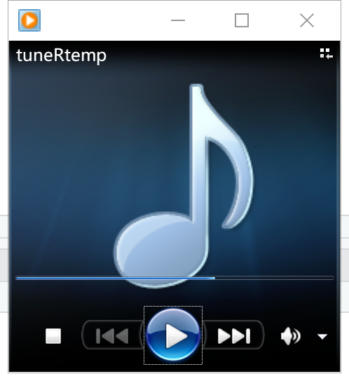

Step2: Generate a Sound

1. Define the duration and the Hz and generalize the wave

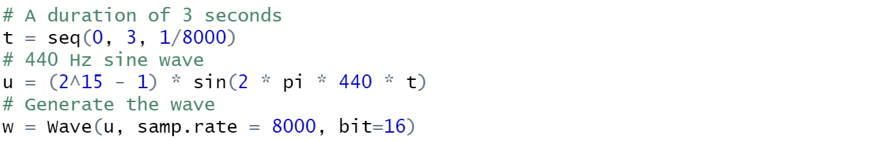

1. Summary the wave and , we can find the results are the same.

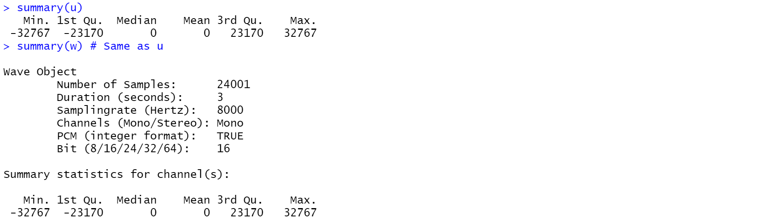

Step3: Play a Series of Notes:

1. Initialization



1. Generate a series of the pitch in random probabilities, we set the probabilities to 0.8, which means that if this time have the 80% to generate note , then the next time have the 80% to generate note .

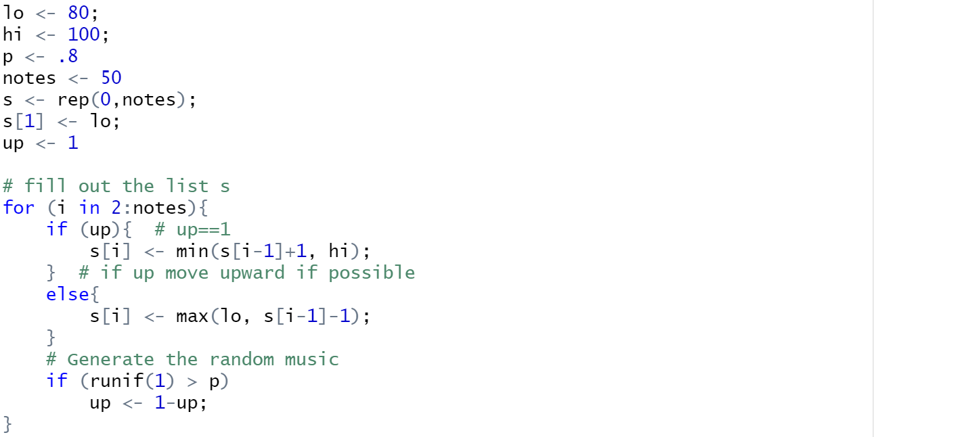

Step4: Convert the sound file to digit

1. Build the note-midi table and based on the table, we can generate the specific music. Here we just need the 5th symphony: by matching the notation of notes.

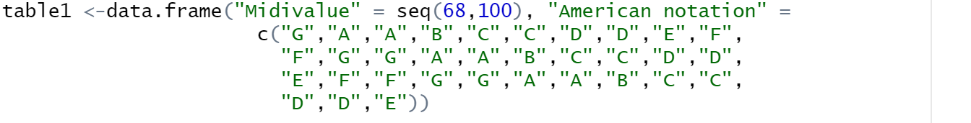

1. At the comment part, we can see the relationship of notes and the midi values and store in a list.

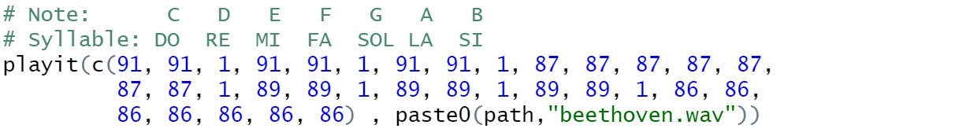

1. Then we can write a function to Convert the sound file to digit (specific value).

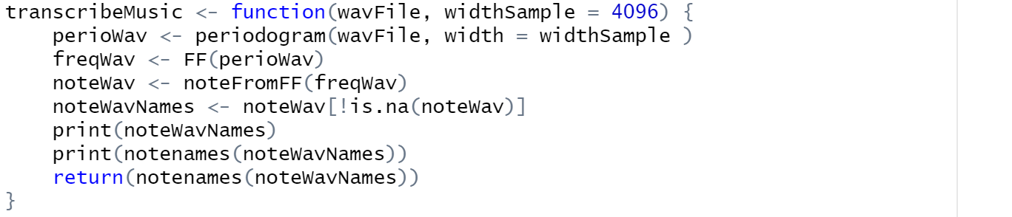

Here we have four steps:

1. Get the object of wave spec.

2. Obtain the fundamental frequencies

3. Acquire the notes from the frequencies in the second step.

4. Remove the data in the end

Step4: Music Mixture

In this part, we should splice the two music with the MP 3 form.

1. Read the mp3 file
2. Use a for loop to divide the two music into .
3. Stack each slice with the .

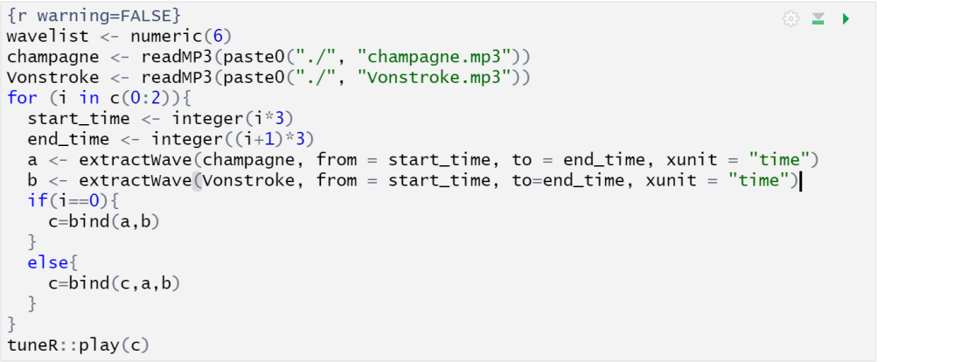

Step5. Stack two slices of music

1. Read the MP3 file first.

2. Read it as an MP3 using the function

3. Write the entire object as wav.

4. Use to get part of music,

5. Stack the pieces together.

And we can see the two example to stack the two parts of music.

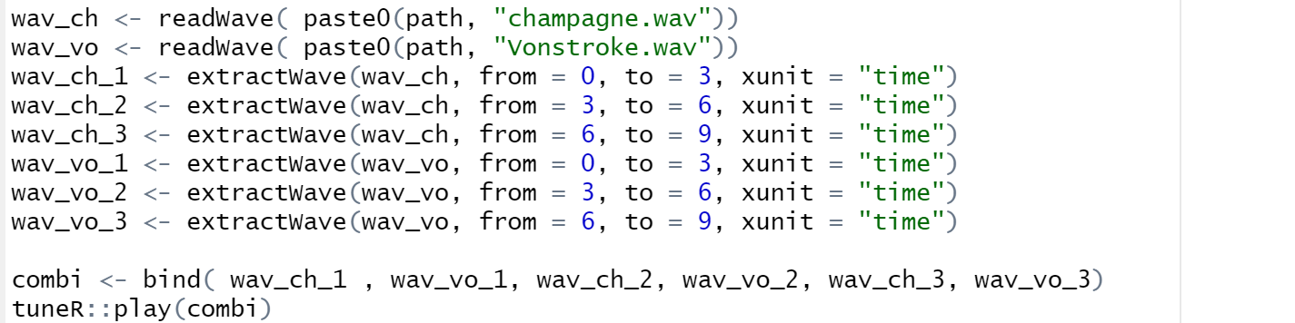

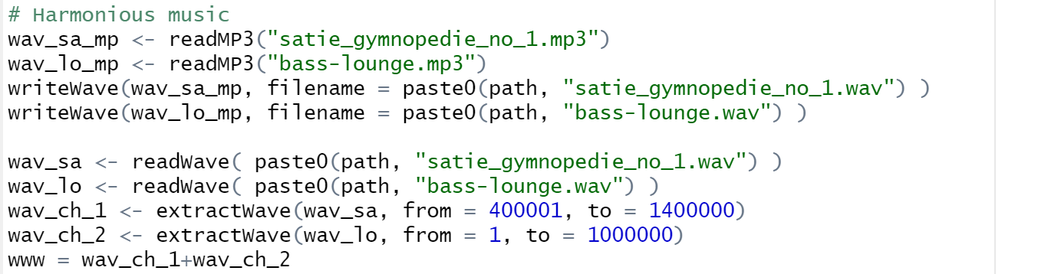

Step6. Mix the two music just use the above example.

1. The first part:

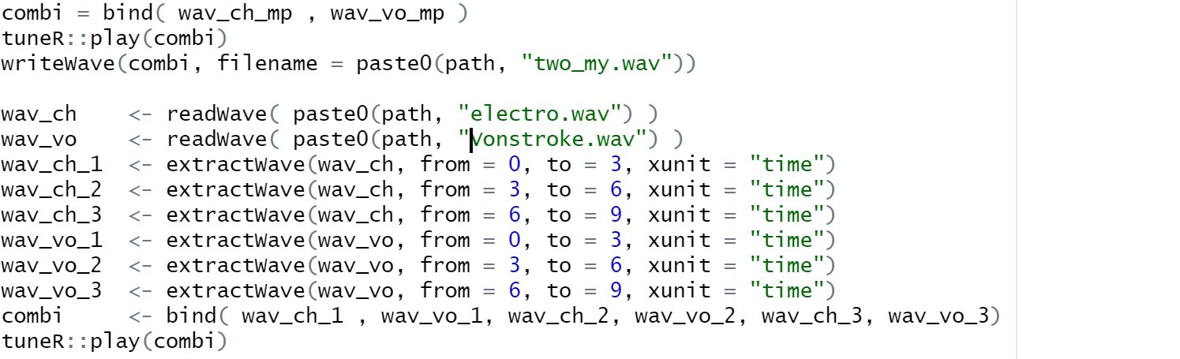

1. The second part:

